**20180320 P384 HT29 starvation 6 hours EGF**

**SUMMARY:**

* Analysis of the pERK signaling pathway by treating HT-29 cells for 24h with different concentrations of BRAF and MEK inhibitors and adding of EGF for 6 hours to re-activate the pathway. The experiment will be done in a 384 well plate.
* 2x 384 Well plates will be seeded with 1000

HT-29 cells per well and treated with different concentrations of drugs inhibiting BRAF and MEK. Combinations of the drugs will also be administered to the cells:

* + Vemurafenib (1 µM) + Cobimetinib

|  |  |  |  |  |  |  |  |  |  |
| --- | --- | --- | --- | --- | --- | --- | --- | --- | --- |
| **Vemurafenib** | 10  µM | 3.16 µM | 1  µM | 0.316 µM | 0.1  µM | 0.0316 µM | 0.01  µM | 0.00316 µM | 0,001  µM |
| **Cobimetinib** | 1  µM | 0.316 µM | 0.1  µM | 0.0316 µM | 0.01 µM | 0.00316 µM | 0.001 µM | 0.000316 µM | 0,0001 µM |
| **Vemurafenib (1uM) + Cobimetinib** | 1  µM | 0.316 µM | 0.1  µM | 0.0316 µM | 0.01 µM | 0.00316 µM | 0.001 µM | 0.000316 µM | 0,0001 µM |

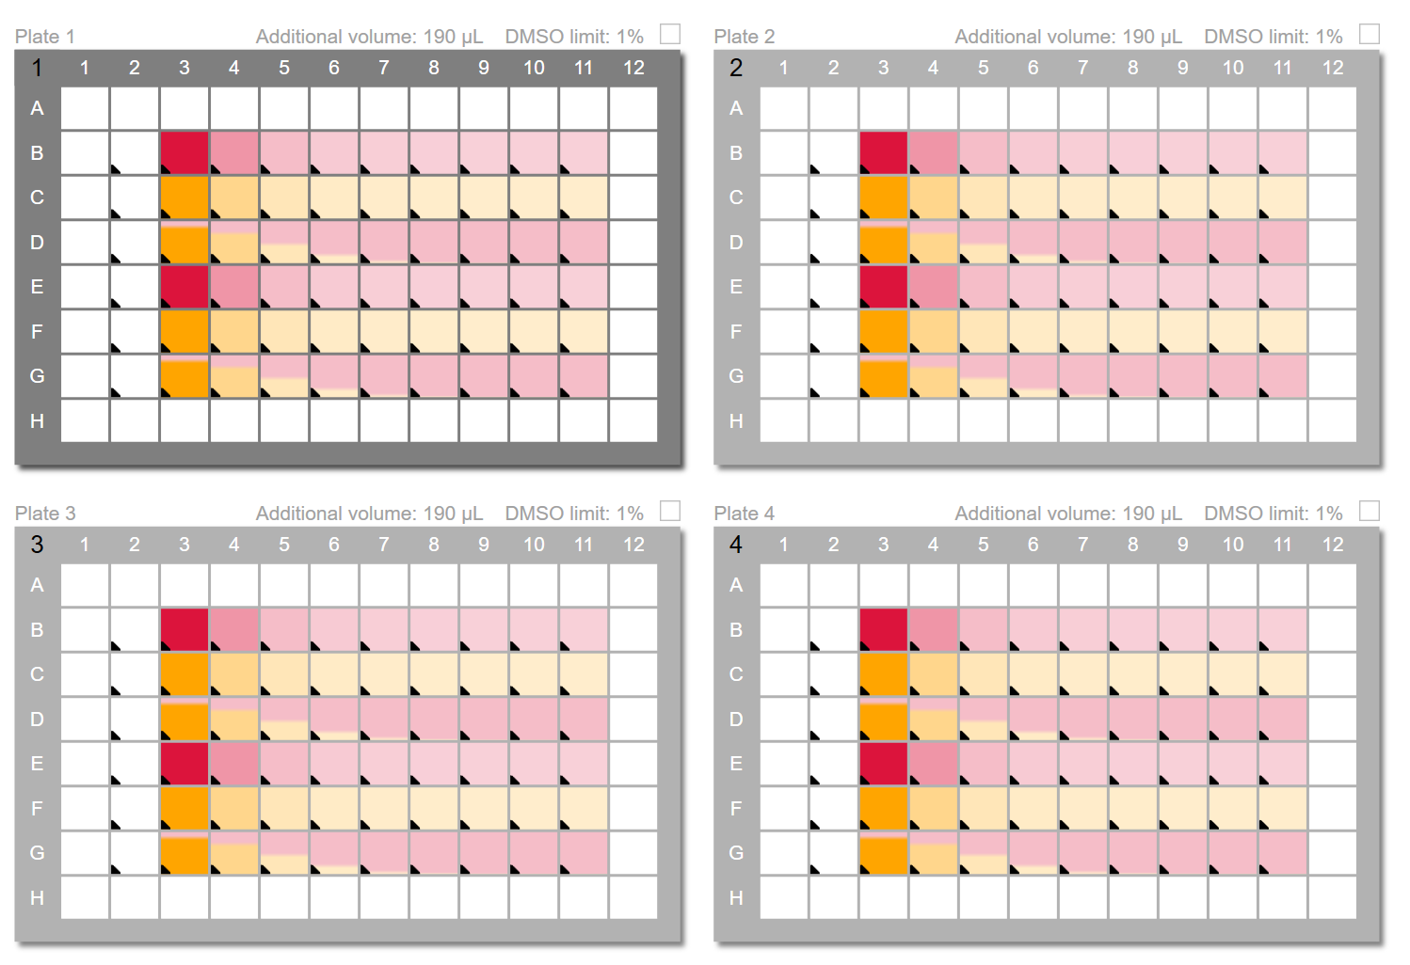

**EGF**

**EGF**

**EGF**

**EGF**

**DMSO**

**DMSO**

**DMSO**

**DMSO**

**MATERIALS:**

* **PRIMARY ANTIBODIES** 
  + pERK Ab (Rabbit)   
    **(CST: 4370)**
* **SECONDARY ANTIBODIES:**
  + Alexa 647 α-rabbit  
    **(Thermo: A31573)**
* **NUCLEI DYE**
  + Hoechst
  + WCD Blue
* **REAGENTS**
  + PFA
  + PBS
  + PBS-T
  + Methanol
  + Odyssey Blocking Buffer

**10 %  
FBS**

**0.5 %  
FBS**

**Monday, March 19th**

Four 96-well Plates (PE, Cell Corning) will be seeded with 1000 cells/well of HT-29 cells. The plates will be seeded using WellMate and the calculations for the cells concentration is described in the Lab book.

**Tuesday, March 20th**

Before treatment, the media of plates 2 & 3 will be changed by fresh media containing only 0.5 % of FBS. After this, the cells will be treated with different concentrations of BRAF and MEK inhibitors. Combinations of drugs will be also used (See above)

**Wednesday, March 21st**

An EGF dilution of 100 ng/µL will be prepared using Media containing 2% BSA. EGF will be added to the bottom part of the plate (**Rows E, F & G**) and the cells will be incubated at 37°C for an **6h** treatment. After that the plates will be fixed and stained with Primary Ab. (See Protocol: “Immunostaining protocol”)

Calculations for EGF dilution:

* Final Volume = 200 µL
* Added Volume/well GF = 10 µL
* GFs Stock conc. = 100 µg/mL
* GFs conc./well = 100 ng/mL
* # Wells = 30 x 10 µL = 300 µL x 4 Plates = 1,2 mL
* Volume = 1,2 mL + dv = **3 mL**

|  |  |  |
| --- | --- | --- |
|  | **Volume from Stock** | **Volume Media** |
| **EGF  (2000 ng/mL)** | 60 µL | 3940 µL |

*Prepare 2% BSA Media: 600 µL of 10 % BSA + 2,4 mL DMEM Media

**Calculations for IF:**

* + 40 µL x 60 wells = 2,4 mL
  + 2,4 mL x 4 Plates = 9,6 mL + dead volume = **12 mL**

|  |  |
| --- | --- |
| **Anti- pERK Ab (Rabbit) (1:800)** | **Odyssey Blocking buffer** |
| 15 µL | 12 mL |

**Calculations for primary Ab:**

**Thursday, March 22nd**

**Calculations for Secondary Ab:**

|  |  |
| --- | --- |
| **α-Rabbit Alexa 647 (1:2000)** | **Odyssey Blocking buffer** |
| 6 µL | 12 mL |

**Calculations for Nuclei Dyes**

|  |  |  |
| --- | --- | --- |
| **Hoechst (1:5000)** | **WCD Blue (1:10000)** | **PBS** |
| 2.4 µL | 1.2 µL | 12 mL |

**Drug and Control Volumes for D300 Dispenser**

**A screenshot of a cell phone

Description generated with very high confidence**